Giancarlos Cyber Defense Lab : Live Honeypot Breach Report (corpna1da)
October 9, 2026

Executive summary
I built and exposed an intentionally weak Windows 11 VM running MySQL (corpna1da) in the Cyber Range, and within 18 hours it was breached by two separate ransom groups. Both got in the same way: the MySQL root@'%' account I created on purpose had a weak password, and the database was reachable from the internet on port 3306.
What happened, in short:
- Wave 1 (Oct 8, 8:52 AM PDT, 45.128.199.171). An automated bot logged into MySQL as root, dumped every table in na_corp_01, sakila and world, dropped 30 tables, and left a Bitcoin ransom note. About 4.15 MB left the VM over the bot’s own MySQL session. The whole wipe took 84 seconds.
- RDP (Oct 8, 12:13 PM PDT, 80.94.95.83). A known mass scanner guessed the weak administrator password and logged on over RDP. Nothing ran under that account and no profile was ever created, so the password was validated but not used.
- Wave 2 (Oct 8, 4:11 PM PDT, 64.89.163.178). A second group logged in as root, dropped every database including Wave 1’s notes, left its own note, wiped the MySQL binary logs, revoked root’s privileges and tried to shut the server down. Total time: 55 seconds.
Bottom line: the MySQL application was fully compromised (data stolen and destroyed). The Windows host itself shows no signs of compromise. The before and after MDE investigation packages show no new services, scheduled tasks, Run keys, accounts or attacker executables. The ransom notes claim the data can be restored for payment, but Wave 1 is the only group that actually took a copy, and Wave 2 had nothing left to take.
All times are Pacific (PDT, UTC minus 7) unless marked UTC

The honeypot environment
corpna1da is a Windows 11 VM (private 10.2.0.36, public 104.209.196.188) in its own resource group, running MySQL Server 8.0, onboarded to Microsoft Defender for Endpoint, and shipping logs to the LAW-Cyber-Range workspace. I named it to look like a real corporate host instead of a lab box.
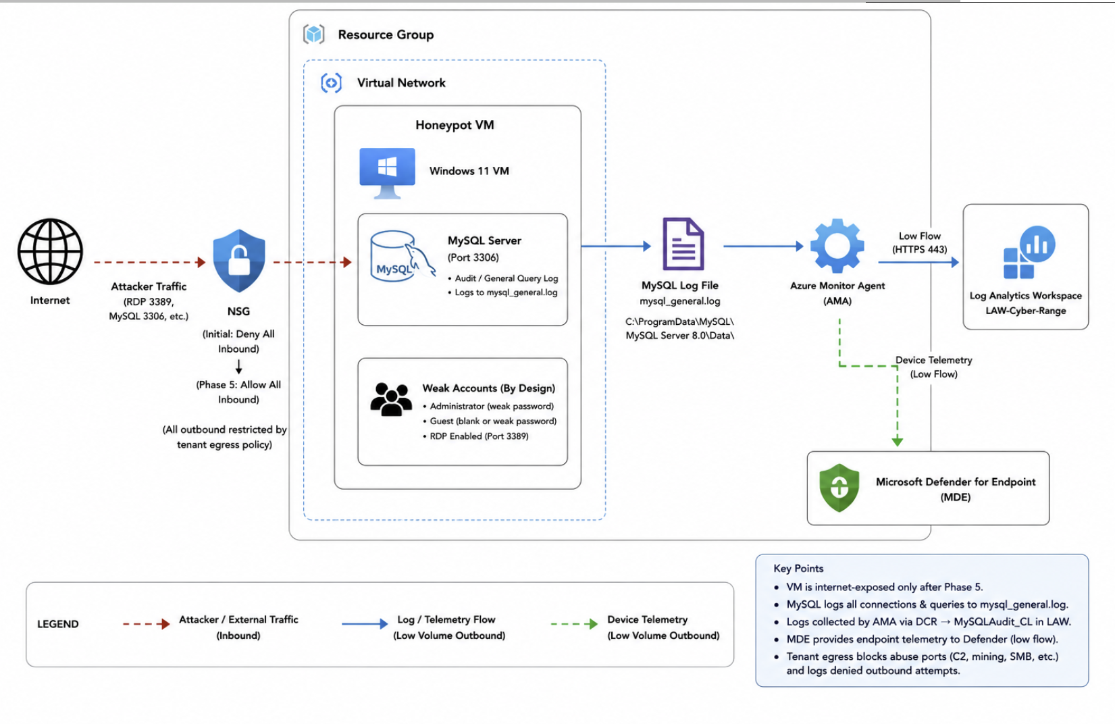
Honeypot topology: attacker traffic through the NSG to the VM, MySQL logs shipped by AMA to Log Analytics, device telemetry to MDE

How I built it
- Build locked down. Deployed the VM with the NSG denying all inbound, onboarded it to MDE and confirmed it in DeviceInfo.
- Install and populate MySQL. Installed MySQL 8.0 with Workbench (service MySQL80, installed Oct 5) and imported dummy company data into na_corp_01: customers, orders, payments and a credentials table with 346 plaintext passwords. The sakila and world sample databases were also present.
- Wire up logging. Turned on the MySQL general query log, swapped in the provided my.ini, and built a custom text log DCR so the Azure Monitor Agent ships mysql_general.log into MySQLAudit_CL.
- Write detections while the box was still clean. Created two Sentinel analytics rules: Tundra-Cyber-Defense-Rule-corpna1da (successful administrator or guest logon to the VM) and Tundra-Cyber-Defense-Final-MySQL (successful MySQL logon).
- Capture the baseline. Collected the first MDE investigation package before opening the box to the internet.
- Weaken and expose. Opened everything up on purpose (table below). Recorded exposure time: Oct 7, 3:15 PM PDT.
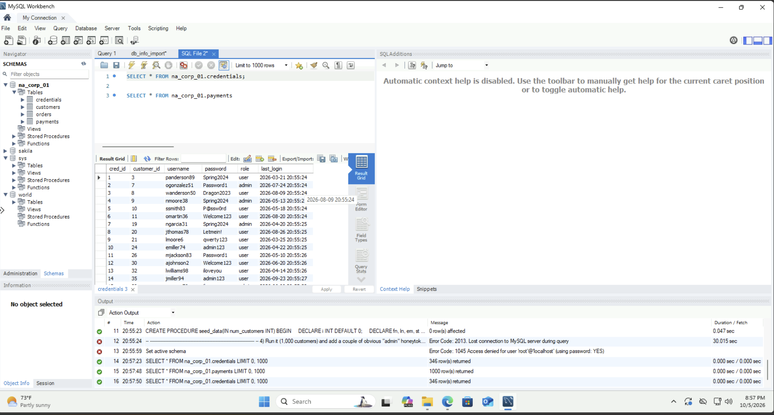
Baseline: the dummy credentials table in na_corp_01 before the breach

Intentional weaknesses
Weakness | When (Oct 7, PDT) | Evidence
administrator account created with a weak password and added to Administrators and Remote Desktop Users | 3:26 to 3:33 PM | Security events 4720, 4732 by lacroix
Guest enabled with a blank password, added to Users and Remote Desktop Users | 3:27 to 3:33 PM | Security events 4722, 4724, 4732
LimitBlankPasswordUse set to 0 | 3:32 PM | Registry
root@'%' created with password root and ALL PRIVILEGES | 3:35:58 PM | MySQL query log
MySQL listening on all interfaces (bind-address = 0.0.0.0) on 3306 and 33060 | Phase 2 | my.ini
Windows Firewall turned off on all three profiles | after 3:39 PM | EnableFirewall changed 1 to 0 between packages
NSG rule DANGER-Allow-All-Inbound allowing any port from any source | after 3:39 PM | NSG flow logs
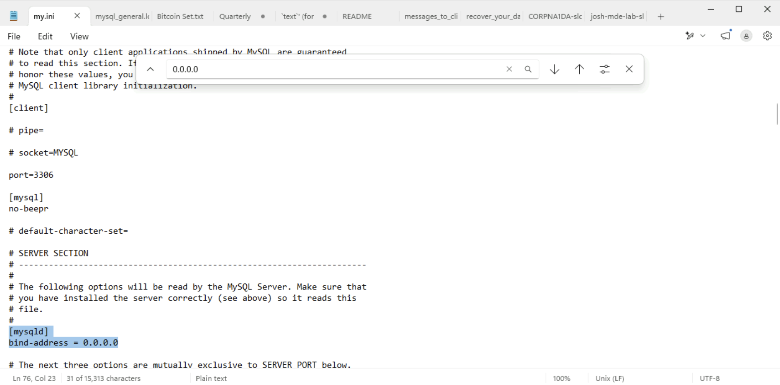
my.ini: MySQL bound to 0.0.0.0, so it accepts connections on every interface

Detections armed before exposure
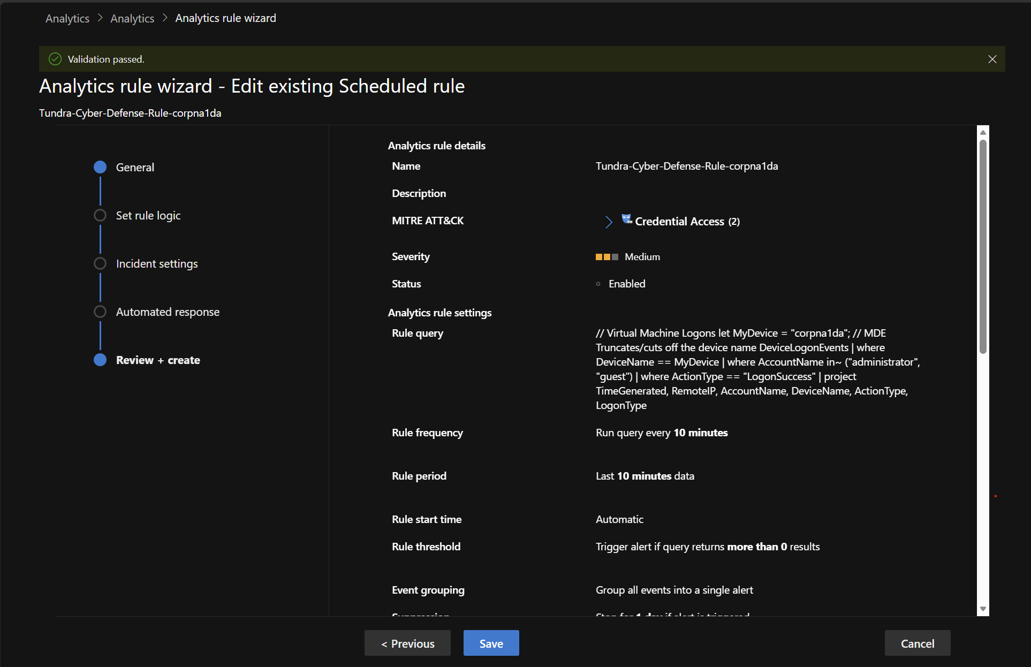
Analytics rule for VM logons: DeviceLogonEvents, administrator or guest, LogonSuccess, every 10 minutes
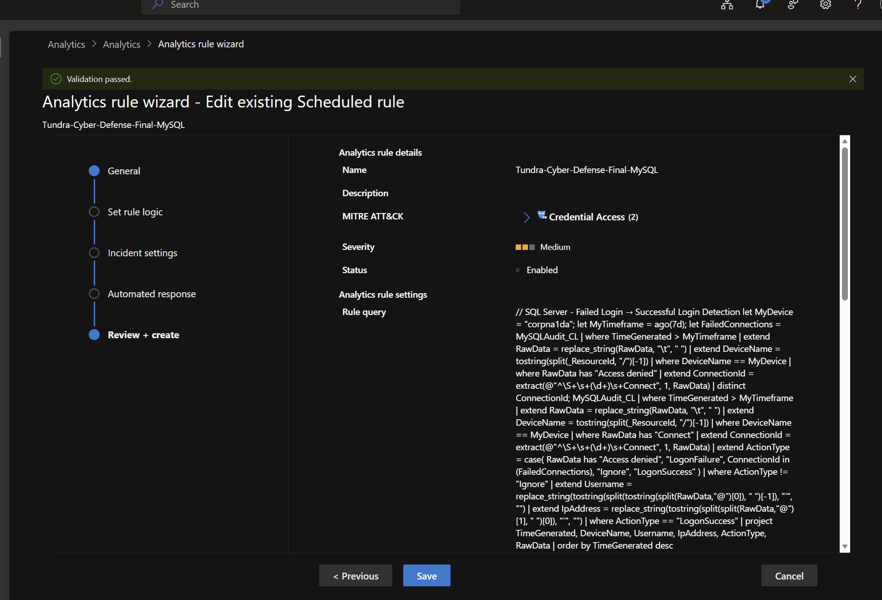
Analytics rule for MySQL logons: parses MySQLAudit_CL into success and failure
The tenant also restricts outbound traffic centrally, so anything a bot tried to call out to (C2, mining pools, SMB) would be blocked and logged. That shaped what I could expect to see: the risk was inbound access and data leaving over the attacker’s own connection, not malware phoning home.

Incident timeline
From my recorded exposure time to the first data theft took 17 hours 37 minutes. Rows in bold are attacker actions that succeeded.
When (PDT) | Source | Event
Oct 7, 3:15 PM | Me | Exposure time recorded; Phase 5 weakening begins
Oct 7, 3:26 to 3:35 PM | Me | administrator and Guest set up; root@'%' created
Oct 7, 3:39 PM | Me | Baseline MDE investigation package collected
Oct 7, after 3:39 PM | Me | Windows Firewall off, NSG opened to all inbound
Oct 7, 4:54 PM | Scanners | First probes of port 3306; 29 different IPs hit MySQL over the next day
Oct 8, 12:47 to 1:02 AM | 80.66.83.43 | RDP brute force, 18 failures
Oct 8, 8:45 AM | 77.90.185.30 | Logs into MySQL as root; runs one query to confirm the password works
Oct 8, 8:52:13 AM | 45.128.199.171 | Wave 1 starts: enumerates all databases
Oct 8, 8:52 to 8:53:37 AM | 45.128.199.171 | Dumps every table, drops 30 tables, plants RECOVER_YOUR_DATA_info notes
Oct 8, 8:54 to 9:45 AM | 59.18.141.14, 82.114.228.224 | RDP brute force continues
Oct 8, 10:01 AM to 12:49 PM | 77.90.185.30 | Checks the root password again, three more times
Oct 8, 10:48 AM | 64.89.163.153 | Failed MySQL root logon (Wave 2 infrastructure)
Oct 8, 12:13:21 PM | 80.94.95.83 | RDP logon as administrator succeeds; nothing runs
Oct 8, 12:20 PM | Sentinel | Incident 235272 created from my VM logon rule
Oct 8, 12:26 to 12:31 PM | Me | RDP in, find and read the Wave 1 note in Workbench
Oct 8, 1:23 PM | 64.89.163.167 | Wave 2 checks the root password
Oct 8, 3:58 PM | Me | Look at the notes again in Workbench
Oct 8, 3:58 PM | Sentinel | Second MySQL alert added to incident 233699
Oct 8, 4:11:14 to 4:12:09 PM | 64.89.163.178 | Wave 2: drops all databases, plants its note, wipes binary logs, revokes root, tries SHUTDOWN
Oct 9, 1:02 AM | Lab schedule | VM auto shutdown
Oct 9, 7:41 AM | Me | VM started again; RDP brute force resumes from new IPs
Oct 9, 7:58 AM | Me | Browsed to a site from the ransom note on the VM (analyst activity, not attacker)
Oct 9, 1:24 PM | 188.132.201.21 | Last external failed logon recorded
Oct 9, 1:38 PM | Me | Post breach MDE investigation package collected
Oct 9, 2:04 PM | Me | VM isolated in Defender; NSG rule deleted

Wave 1: MySQL theft and wipe (45.128.199.171)
Wave 1 was a two step operation: a checker IP confirmed the password, then an attack IP did the damage seven minutes later.
The checker (77.90.185.30). Every visit followed the same pattern: try root with no password, then admin, then sa, then root with the real password, which worked on the first real attempt. It then ran only SELECT @@max_allowed_packet and left. That is a credential list being replayed, not a brute force. It came back at 10:01 AM, 11:33 AM and 12:49 PM. Defender threat intelligence shows this IP in 10,007 alerts across 9,668 incidents (limited network ltd, ASN 213790, UK).
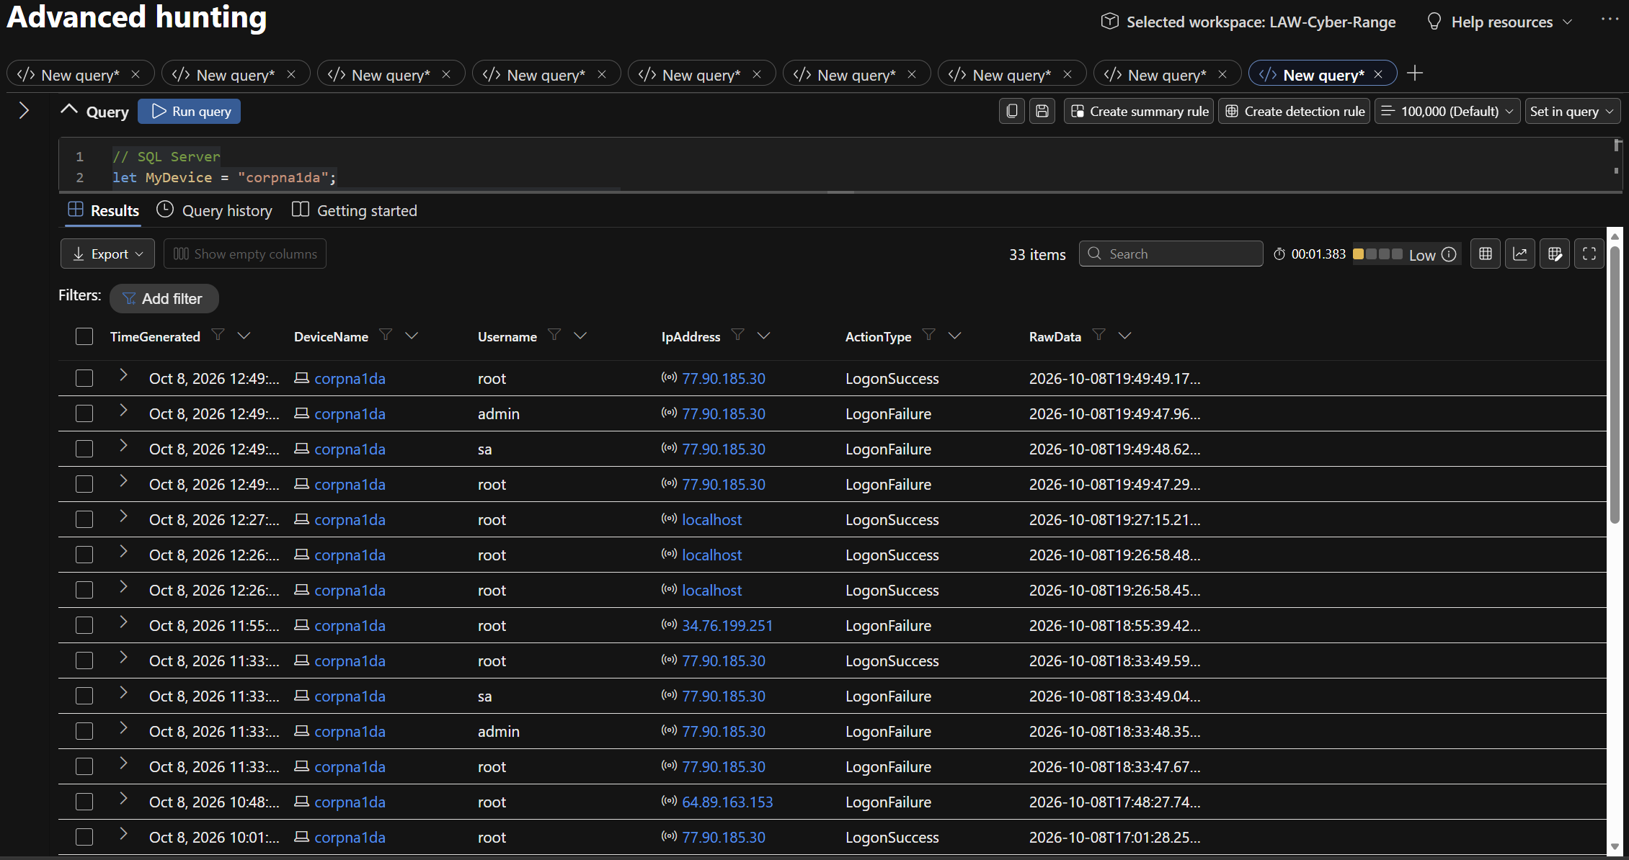
MySQL logons parsed from MySQLAudit_CL: the 77.90.185.30 pattern of root, admin, sa, then a root success
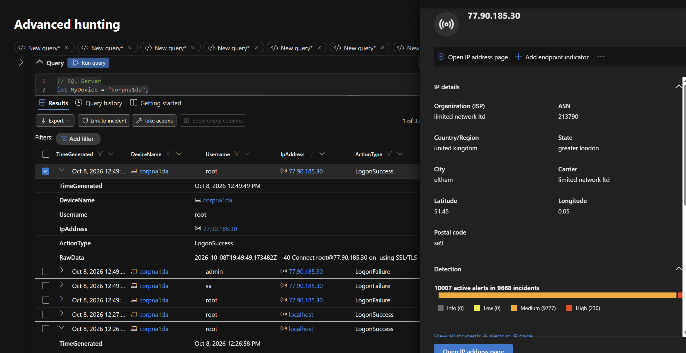
77.90.185.30 in Defender: 10,007 active alerts in 9,668 incidents
The attack (45.128.199.171). It logged in with no failed attempts, opened four sessions, and ran a mysqldump style collection (LOCK TABLES, SHOW CREATE TABLE, then SELECT /*!40001 SQL_NO_CACHE */ * FROM every table). Right after each database was dumped, it created the note table, inserted the note and dropped the real tables.
Database | Tables dumped | Objects dropped | Dumped then dropped (UTC)
na_corp_01 | credentials, customers, orders, payments | 4 | 15:52:18 to 15:52:30
sakila | 16 tables plus 7 view definitions | 23 | 15:52:34 to 15:53:23
world | city, country, countrylanguage | 3 | 15:53:26 to 15:53:37
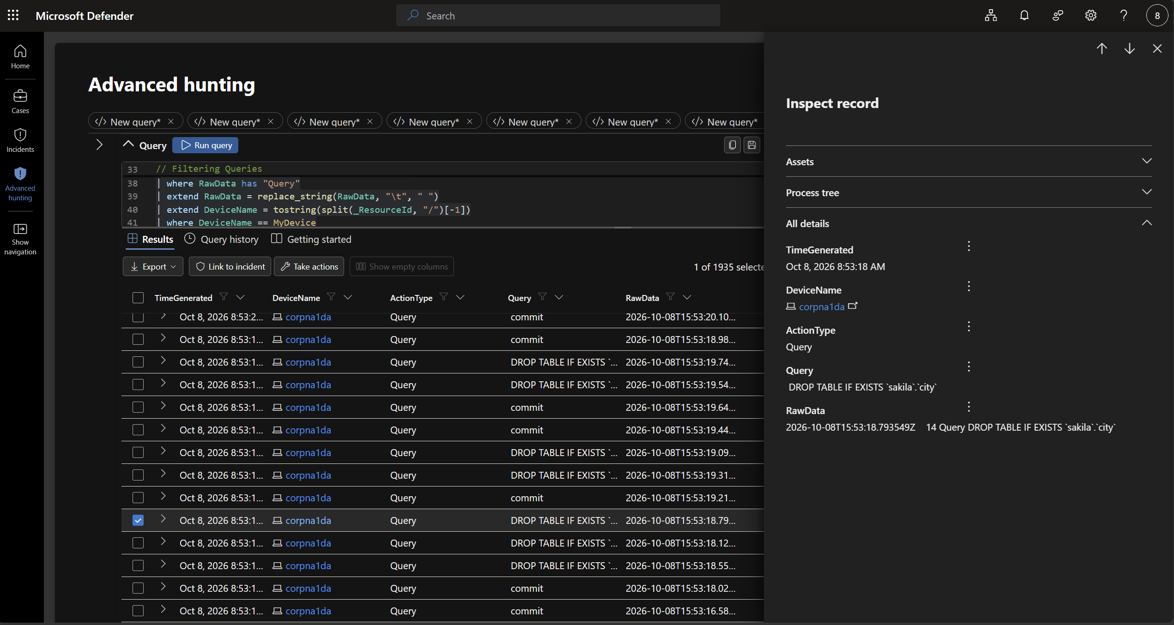
The DROP TABLE run in the query log
The data really did leave. The NSG flow record for 45.128.199.171 on port 3306 shows 4 flows with 282,749 bytes in and 4,153,763 bytes out. The four flows match the four sessions, and 4.15 MB is the size of three full dumps. mysqld.exe made no outbound connections at all, so the data went back over the attacker’s own inbound session. That is also why the tenant egress block never saw it.
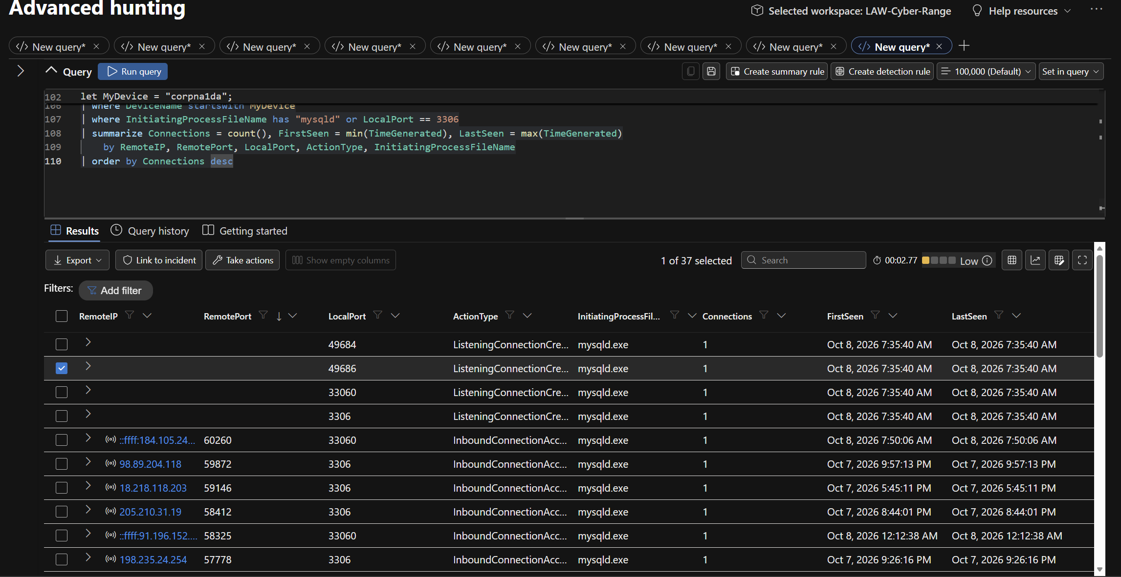
mysqld.exe network activity: inbound only, from 29 external IPs
The note. Each wiped database got a RECOVER_YOUR_DATA_info table with one READ_ME column asking for 0.01 BTC (restore and no leak) or 0.005 BTC (no leak only) to bc1q6axq3n2trxewd04cczsvtk7jqn6qp34d66cust, with a 30 day deadline. It tells the victim not to change the password and to keep the database reachable from the internet, which only helps the bot log back in. The IP in the note (104.209.196.188 plus root) is my VM’s own IP and the account it broke into, not the attacker. The bot also ran SHOW DATABASES LIKE 'mat_server' first, which looks like a fingerprint of the tool.
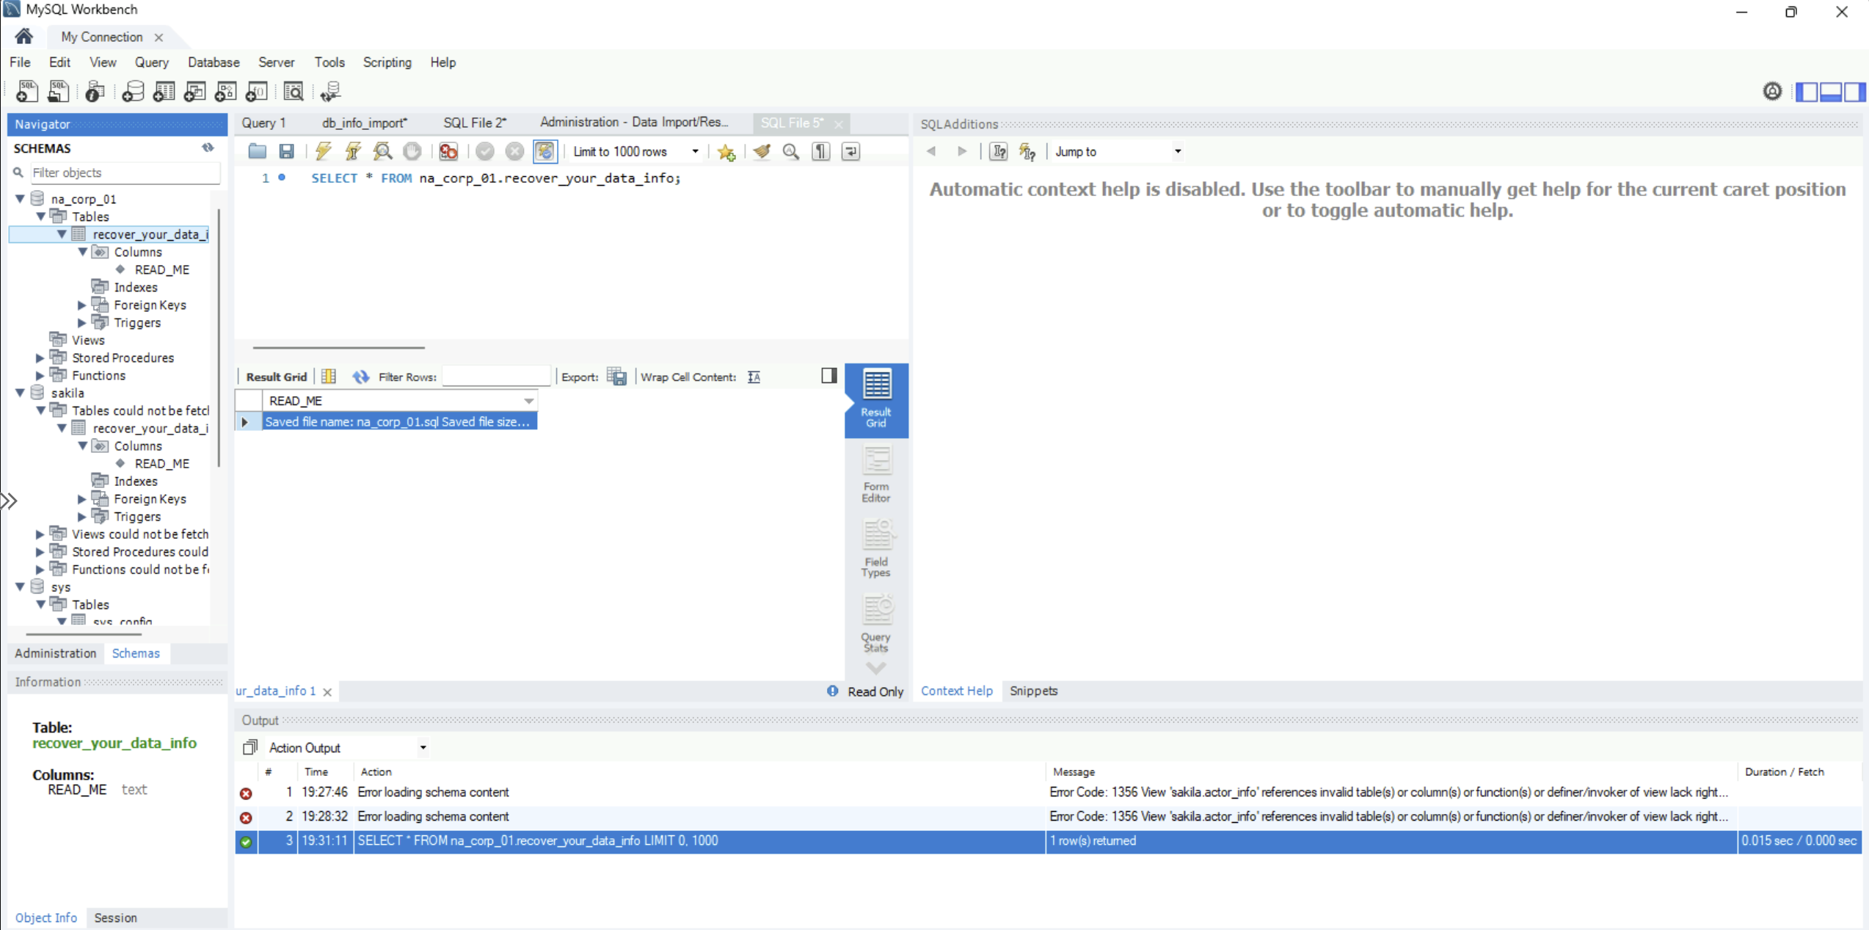
The Wave 1 note in MySQL Workbench
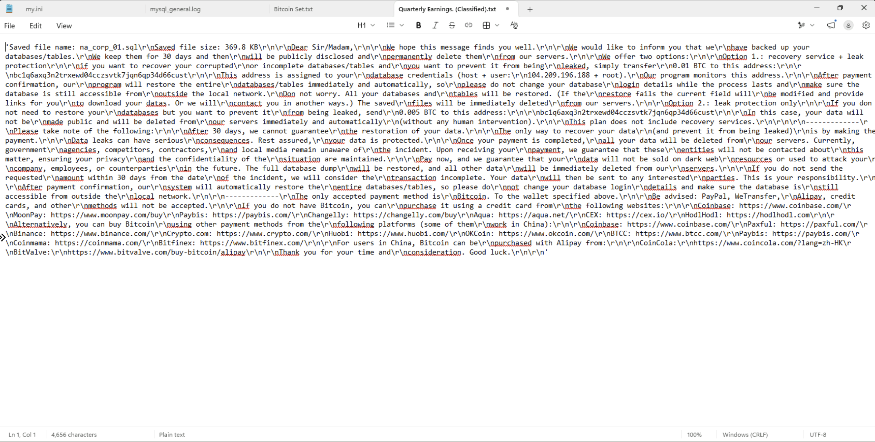
The full Wave 1 note text
The bot sent DROP TABLE against sakila’s views too, which does not remove a view. The views survived with nothing underneath them, which is why Workbench threw Error 1356 on sakila.actor_info when I first opened it.
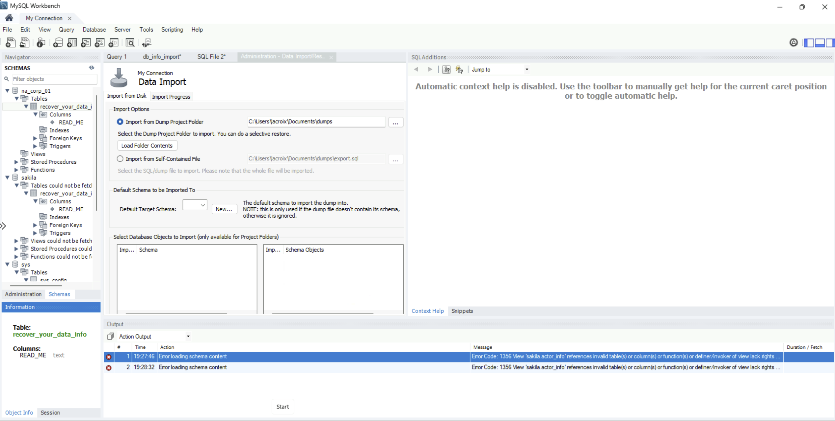
Error 1356 in Workbench: views left pointing at tables that no longer exist

RDP brute force and the administrator logon (80.94.95.83)
The RDP side of the honeypot got hit constantly, and one bot did guess the weak administrator password. It never used it.
Source IP | Failed logons | When | Result
59.18.141.14 | 39 on Oct 8, 218 on Oct 9 | Oct 8 and 9 | All failed
80.66.83.43 / 80.66.83.80 | 18 on Oct 8, 88 on Oct 9 | Oct 8 and 9 | All failed
175.139.147.237 | 38 | Oct 9 | All failed
82.114.228.224, 138.91.109.48, 181.42.225.2, 188.132.201.21 | 21 combined | Oct 8 and 9 | All failed
80.94.95.83 | 0 | Oct 8, 12:13:21 PM | LogonSuccess as administrator
On Oct 9 alone the Security log shows 362 failed logons and 13 lockouts of administrator, about every 18 minutes. I didn’t configure a lockout policy, so that is the Windows 11 default doing its job.
80.94.95.83 is a well known mass scanner: Defender threat intelligence has it in 4,905 alerts across 4,563 incidents (unmanaged ltd, ASN 204428, UK). It logged on with a network logon followed by a RemoteInteractive logon, and the session ended within seconds.
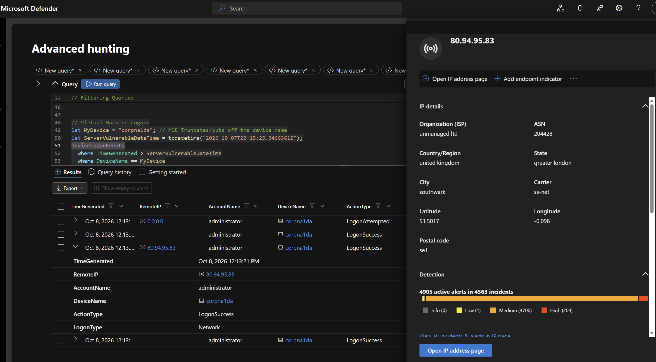
80.94.95.83 in Defender: LogonSuccess as administrator, and 4,905 active alerts in 4,563 incidents
Why I believe nothing happened after the logon:
- No C:\Users\administrator profile exists in either investigation package. A real desktop session creates one.
- The BAM registry key, which records programs each user runs, has no entries for the administrator account.
- Prefetch shows nothing new running between 12:12 and 12:25 PM.
- DeviceProcessEvents, DeviceFileEvents and DeviceRegistryEvents show no activity under any account except mine and SYSTEM.
So the bot validated the password and moved on, most likely to add it to a list. It still counts as a compromised credential.
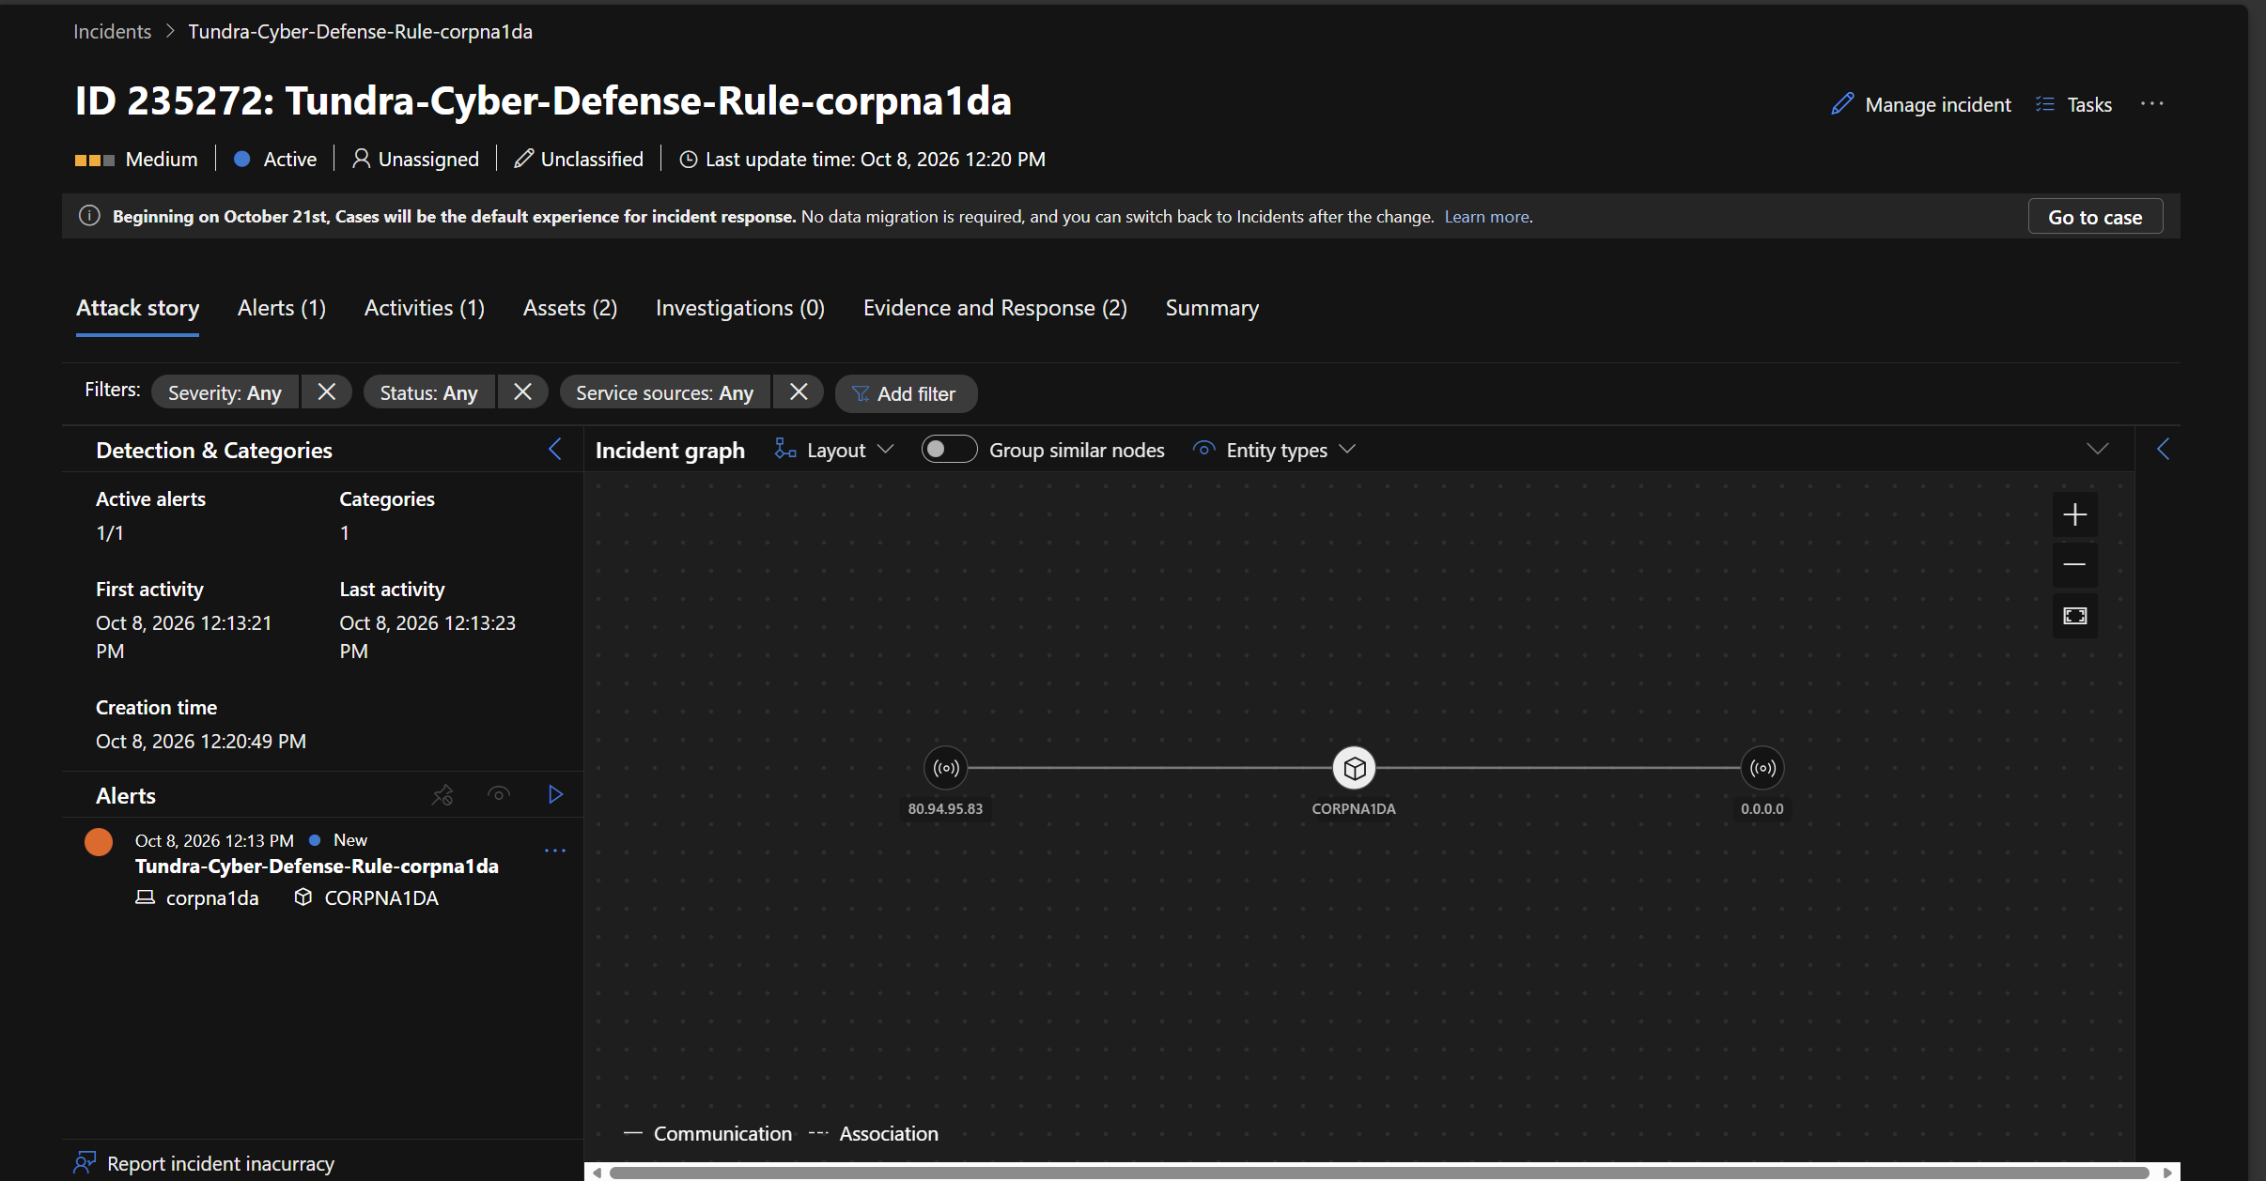
Incident 235272 from my VM logon rule, linking 80.94.95.83 to CORPNA1DA

Wave 2: second ransom group (64.89.163.178)
A different group came through the same open door about seven hours after Wave 1. It used three IPs from the same 64.89.163.0/24 range: .153 failed at 10:48 AM, .167 confirmed the password at 1:23 PM, and .178 ran the attack at 4:11 PM. The two attack visits share the same habits: a blank password try first, then the real password, then SET AUTOCOMMIT=0.
Time (Oct 8, PDT) | What it did
4:11:14 | Blank password try fails, real password works on the next connection
4:11:26 | CREATE DATABASE RECOVER_YOUR_DATA, inserts its note
4:11:30 | GRANT CREATE, DROP ON *.* TO root@'%'
4:11:32 to 4:12:00 | Sizes each database, lists tables, reads only the Wave 1 notes (SELECT * FROM recover_your_data_info)
4:12:01 | DROP DATABASE on na_corp_01, recover_your_data, sakila and world
4:12:02 | Recreates RECOVER_YOUR_DATA with its note
4:12:04 | RESET MASTER, then PURGE BINARY LOGS
4:12:05 | REVOKE ALL PRIVILEGES, GRANT OPTION FROM root@'%'
4:12:06 | GRANT SHUTDOWN, then SHUTDOWN
4:12:07 | SELECT JSON_SCHEMA_VALID(...) with a very long string of A’s
4:12:08 | SHOW DATABASES to confirm, then disconnects
The note asks for 0.0103 BTC to bc1qt6kstjjdatqnxd3ksdcfv0jnhdjzndcnkx8zla within 48 hours, points to https://cuq.in/844 (a URL shortener), and says to email ak+2s3ft@onionmail.org with DATAID 2S3FT. The victim ID matches the email’s plus tag, so this group likely uses one mailbox and tags it per victim.
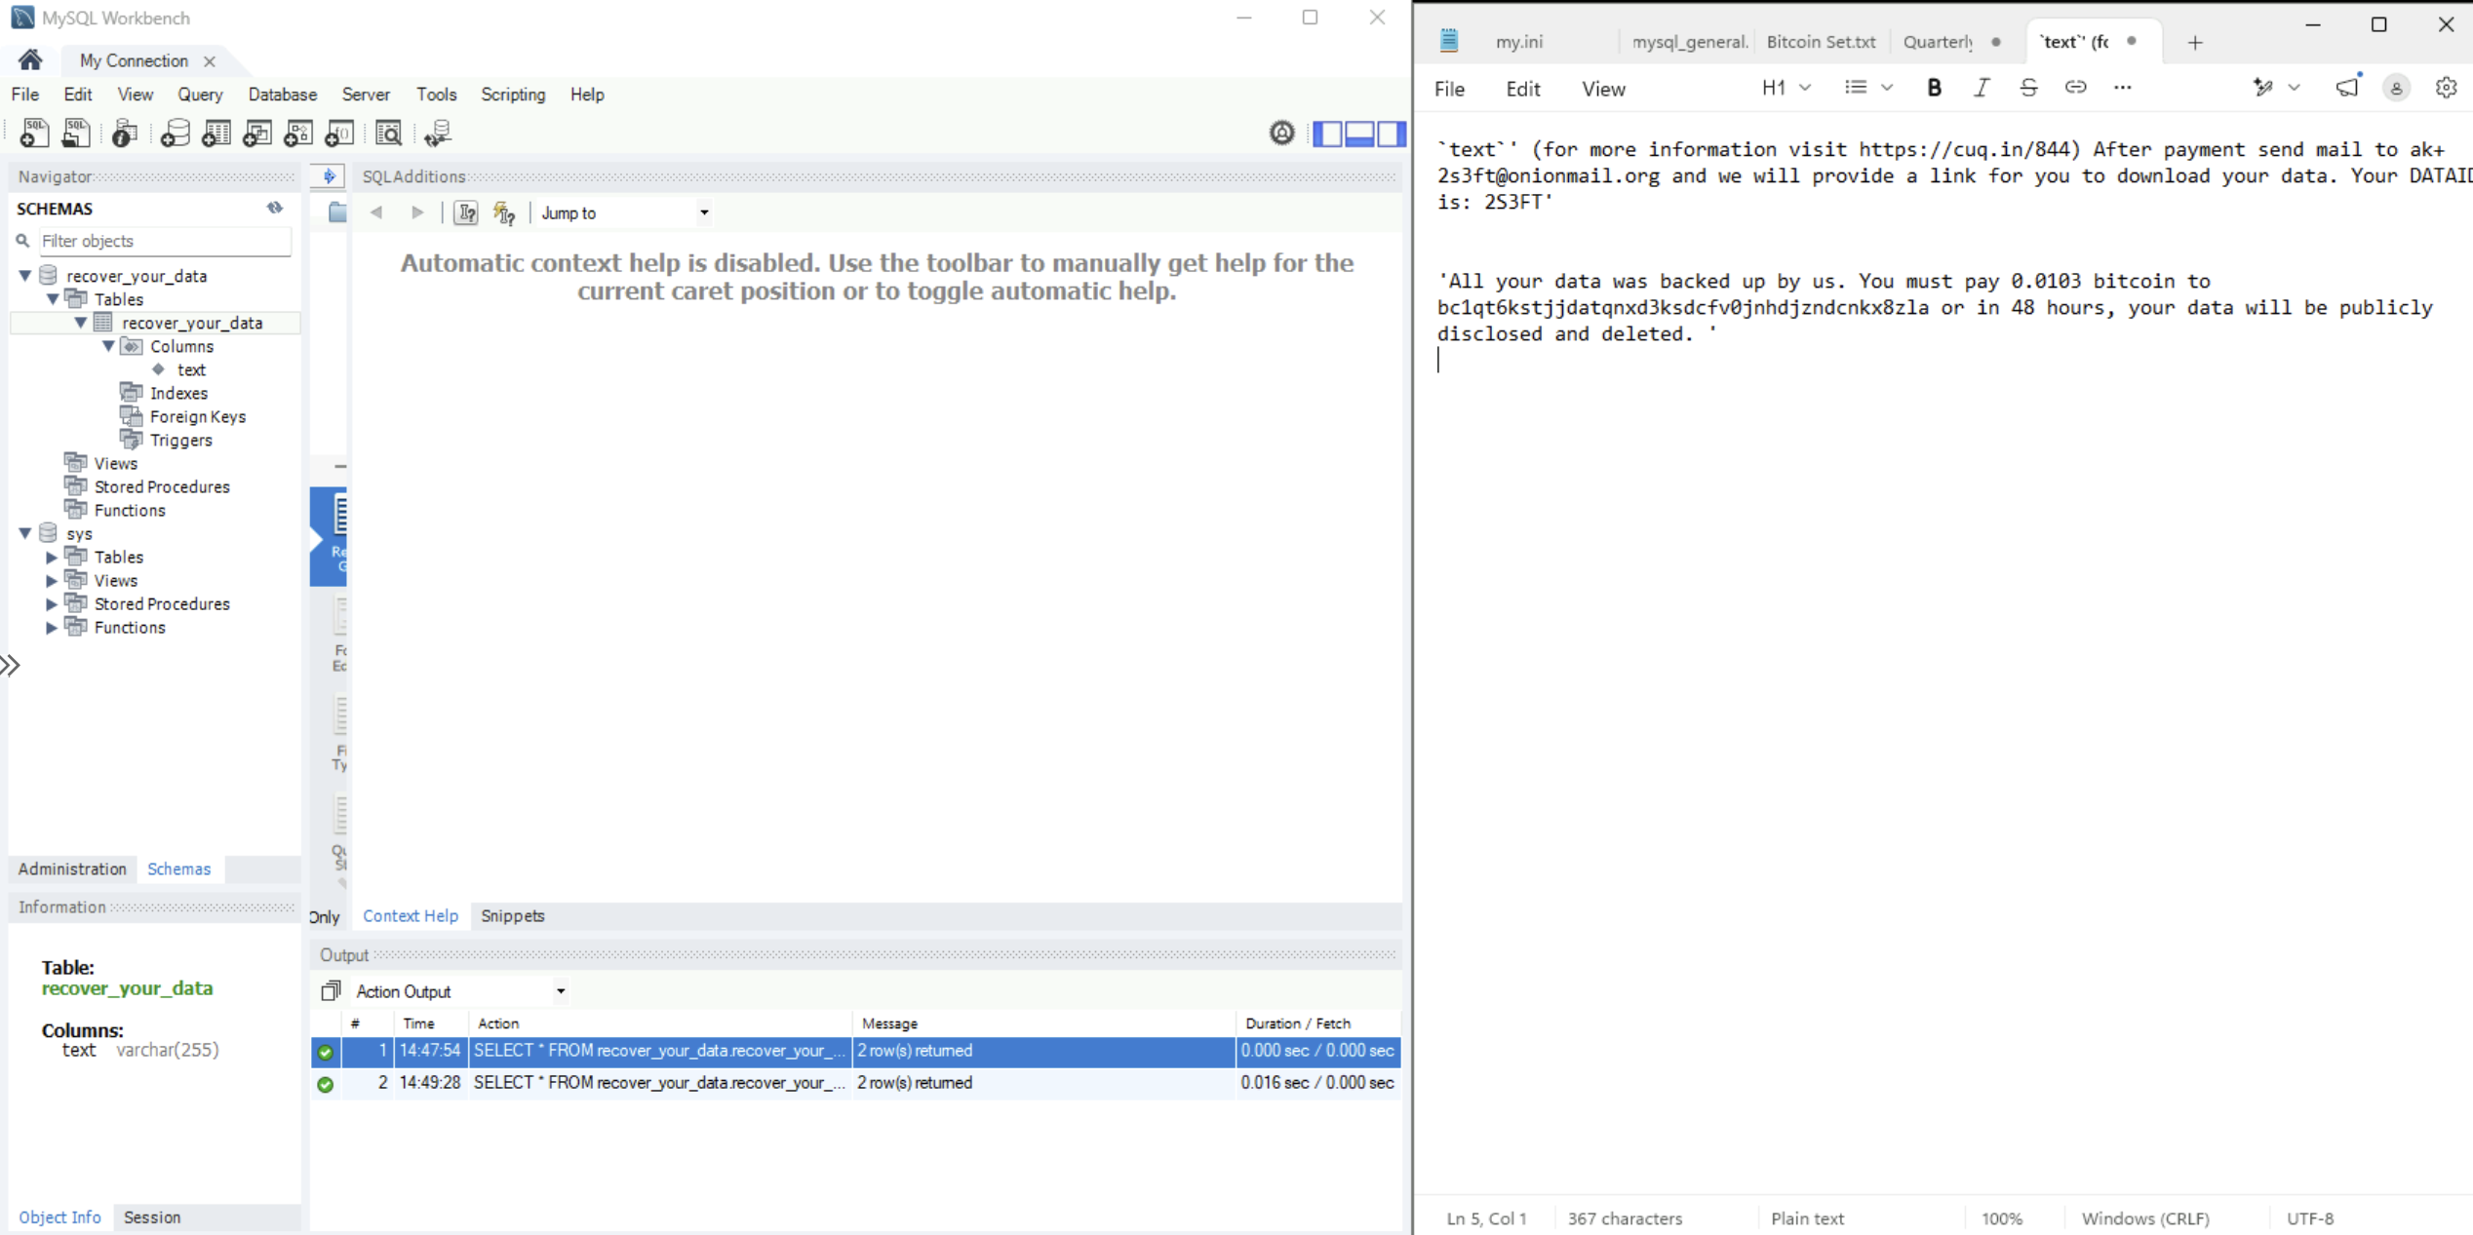
The Wave 2 database and note: recover_your_data with a text column, and the note text
What stands out:
- It stole nothing real. Wave 1 had already dropped every real table. The only data Wave 2 read was the other group’s notes and table sizes, so its “we backed up your data” claim is false.
- It covered its tracks. RESET MASTER and PURGE BINARY LOGS wiped the MySQL binary logs. Defender’s real time protection log caught the side effect: josh-mde-lab-bin.index rewritten and the old index renamed .deleted at 23:12:04 UTC. The general query log survived only because AMA had already shipped every line to Log Analytics.
- It tried to lock me out and take the server down. It revoked root’s privileges, then ran SHUTDOWN. The shutdown failed: Defender’s log shows the same mysqld.exe process (PID 4316) still running afterward, and the query log kept recording.
- The JSON_SCHEMA_VALID call with an oversized string looks like a crash or exploit probe. The server stayed up, so I can’t say what it was aiming for.
Defender recorded the drop on disk too: mysqld.exe touched the old note files in all three databases and created recover_your_data\recover_your_data.ibd within one second at 23:12:01 UTC.

Detection, containment and response

How the detections performed
Rule | What it caught | What it missed
Tundra-Cyber-Defense-Rule-corpna1da (VM logon, every 10 minutes) | The 80.94.95.83 administrator logon. Incident 235272 created 7 minutes after the logon | Nothing in scope
Tundra-Cyber-Defense-Final-MySQL (MySQL logon) | Two alerts in incident 233699 | Every attacker logon. Both alerts fired on my own root@localhost Workbench sessions
The MySQL rule’s first alert started at Oct 7, 3:35:27 PM, which is the exact second of my own setup login. The second alert’s activity ends at Oct 8, 3:58:53 PM, which is the exact second I opened Workbench again. Neither Wave 1 (8:52 AM) nor Wave 2 (4:11 PM) produced an alert of its own. The gap between the two alerts (about 24 hours) is consistent with a one day alert suppression window, which would have muted both waves. The rule also looks back 7 days and doesn’t filter out localhost, so my own admin activity kept tripping it.
The incident graph only showed the host, because the MySQL rule maps only one entity. Mapping IpAddress and Username would put the attacker IPs on the graph.
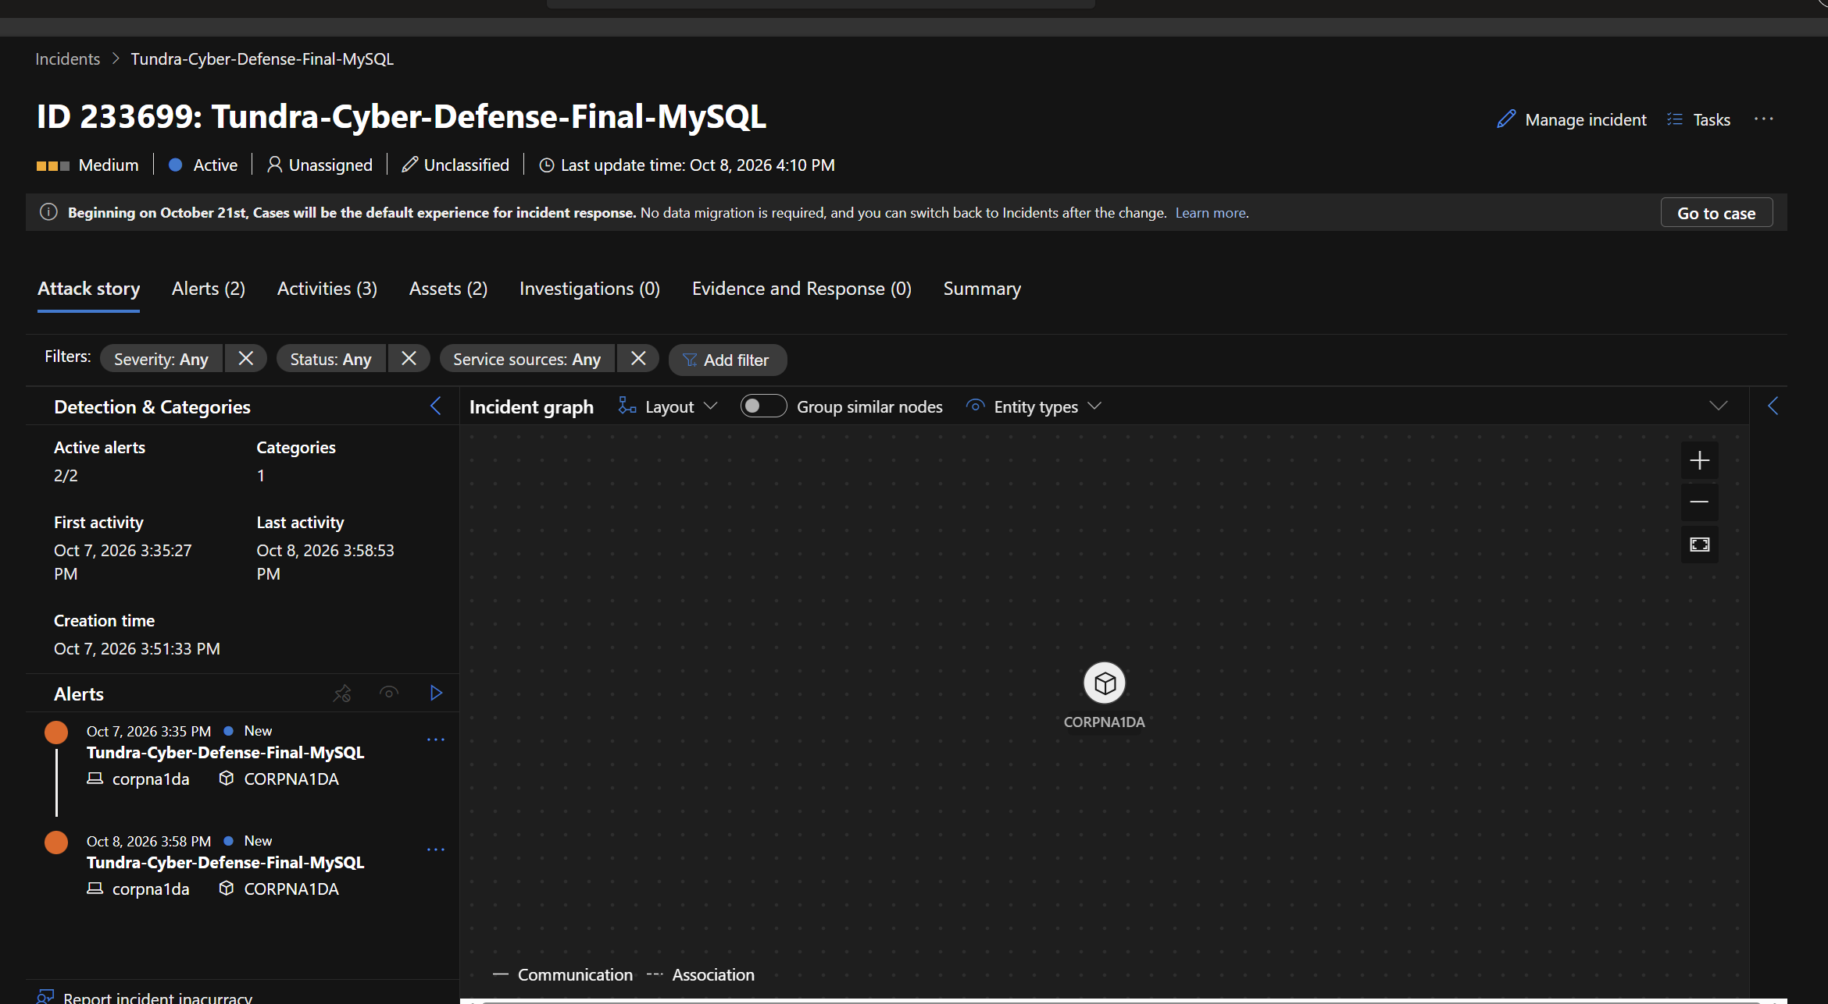
Incident 233699 from the MySQL rule: both alerts on corpna1da, first activity Oct 7 3:35 PM, last activity Oct 8 3:58 PM

Exposure as Defender saw it
Defender flagged the device as internet facing from its own external scan, and the device’s risk and vulnerability count kept climbing while it sat exposed.
 | Earlier device page | At isolation
Risk level | No known risks | High
Tags | none | Internet facing
Discovered vulnerabilities | 108 (9 critical) | 327 (22 critical)
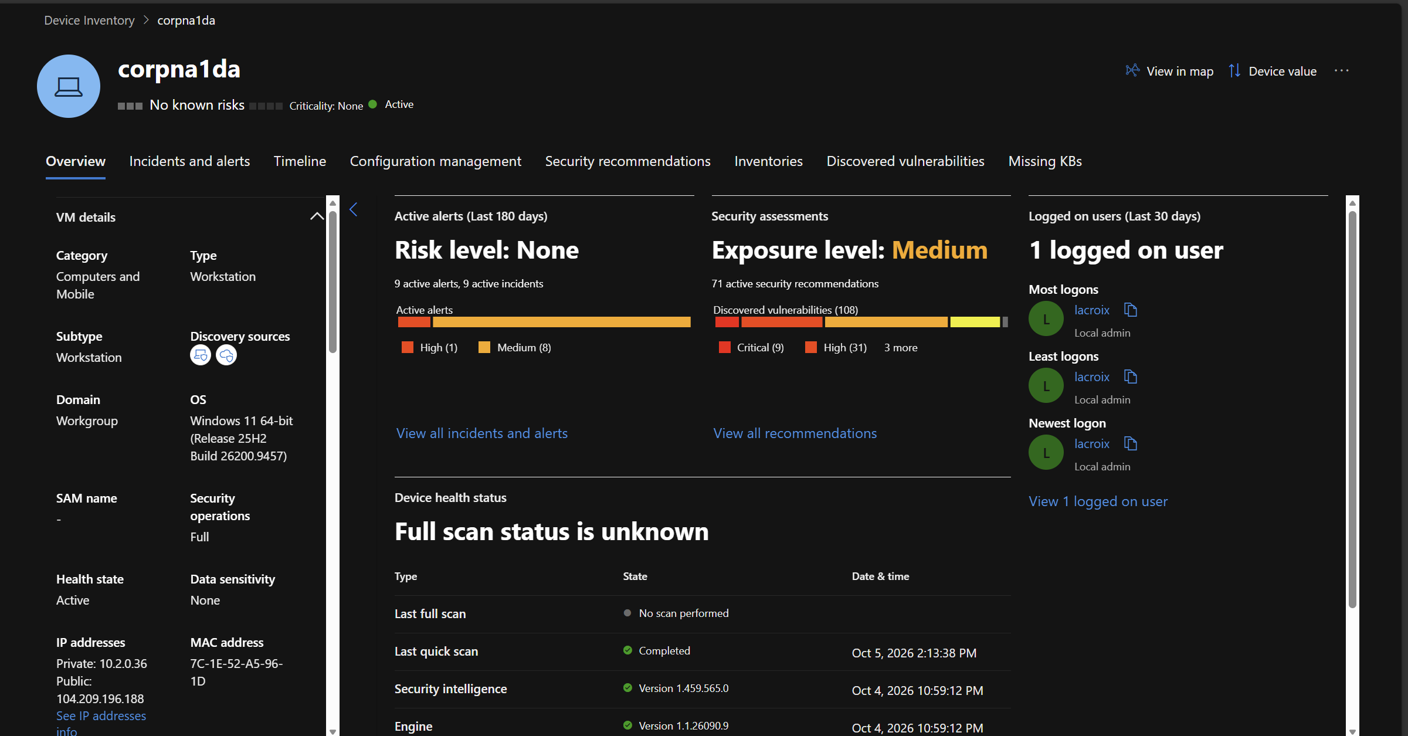
Earlier device page: no known risks, 108 vulnerabilities
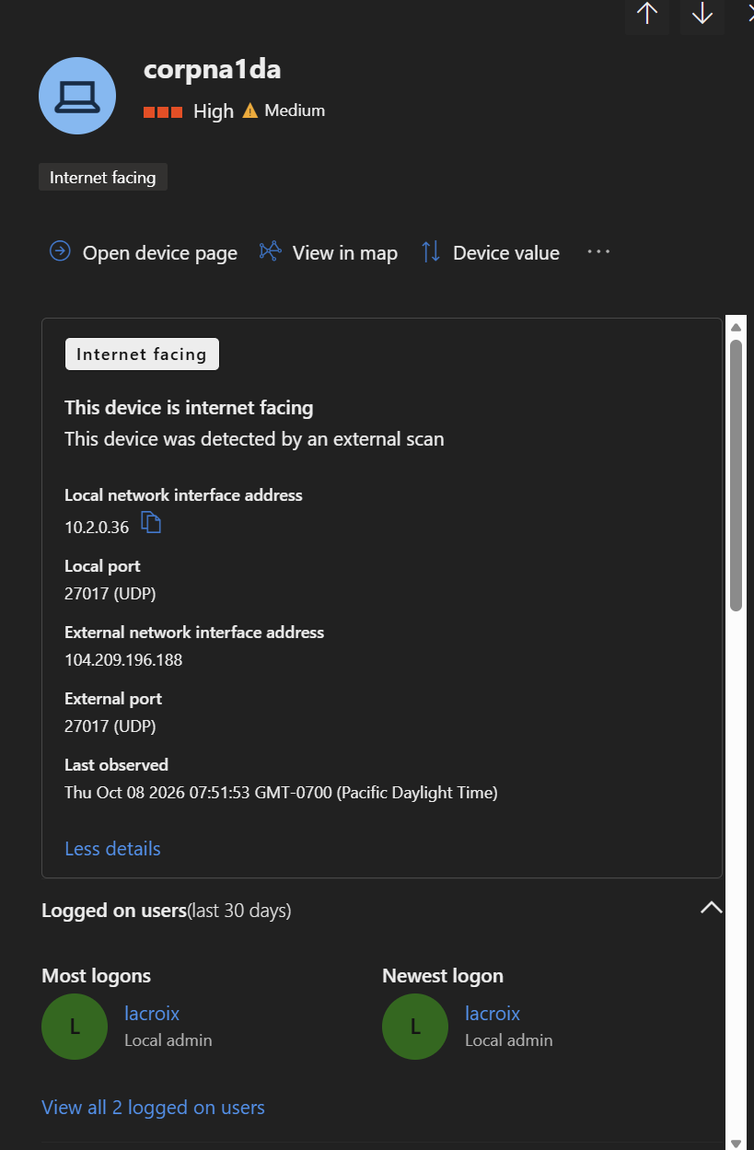
Internet facing tag: detected by an external scan on 104.209.196.188
The NSG flow logs show how loud the internet is. In one hour (8:49 to 9:49 AM on Oct 8) the VM received 31,465 inbound flows from 368 public IPs, all allowed. One address, 79.124.56.214, scanned 30,702 ports by itself.
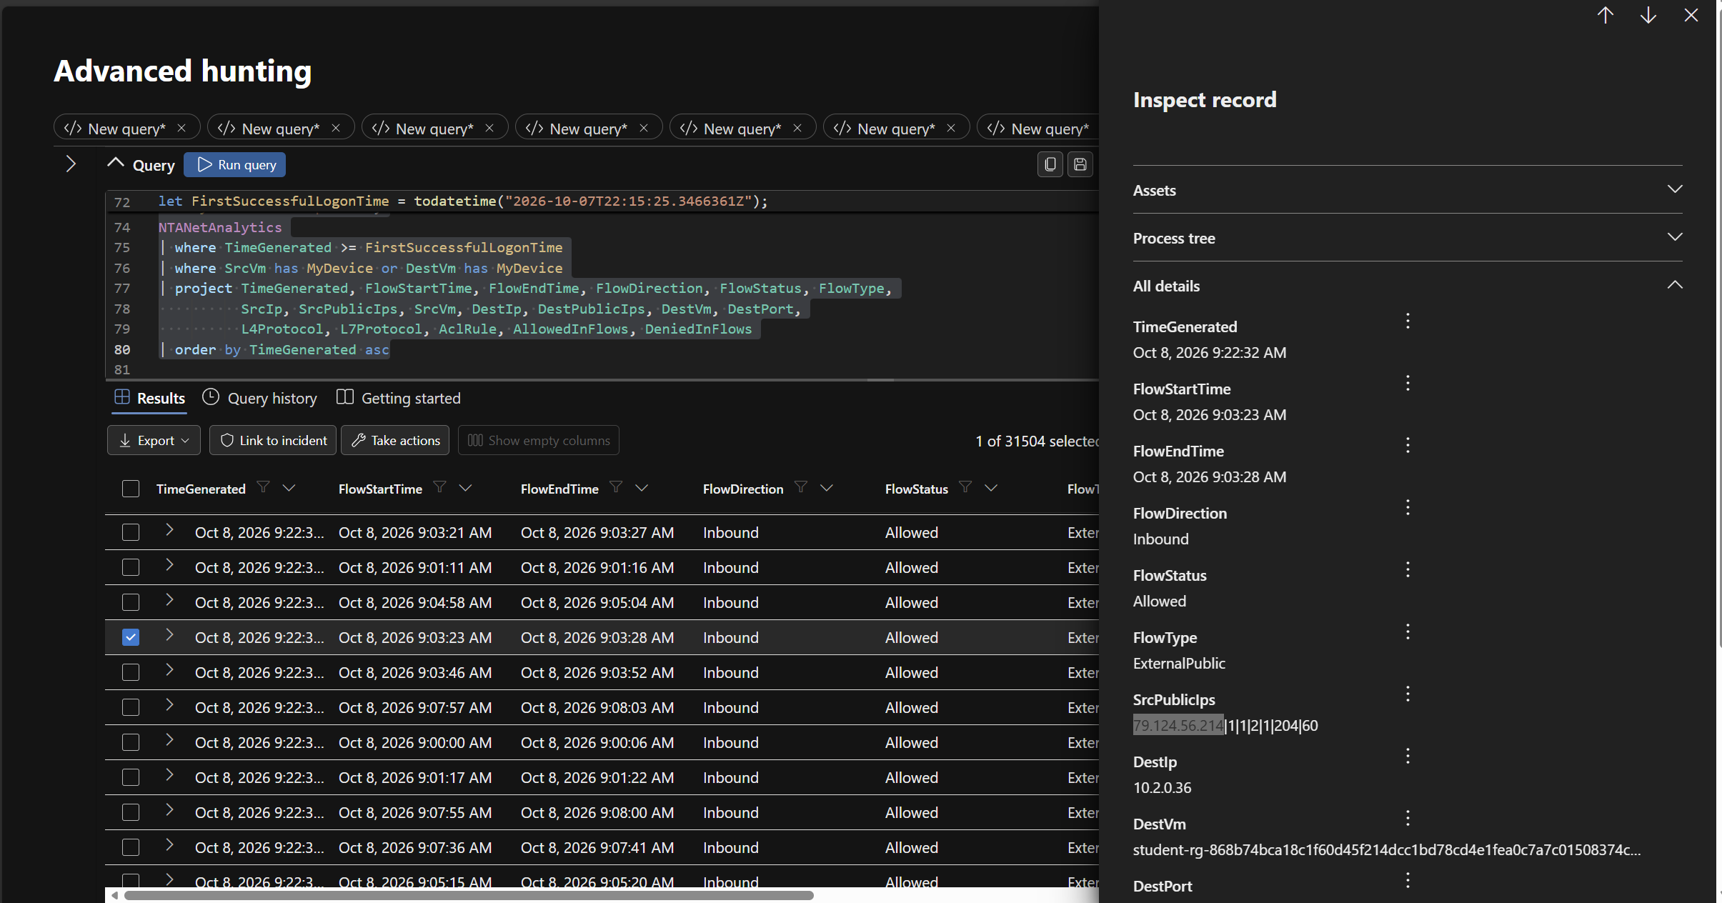
NSG flow logs: 79.124.56.214 sweeping ports on the VM

Containment
On Oct 9 I collected the post breach investigation package at 1:38 PM, then isolated the VM in Defender at 2:04:02 PM with the comment “Tundra Post-Breach Isolation” and deleted the DANGER-Allow-All-Inbound NSG rule.
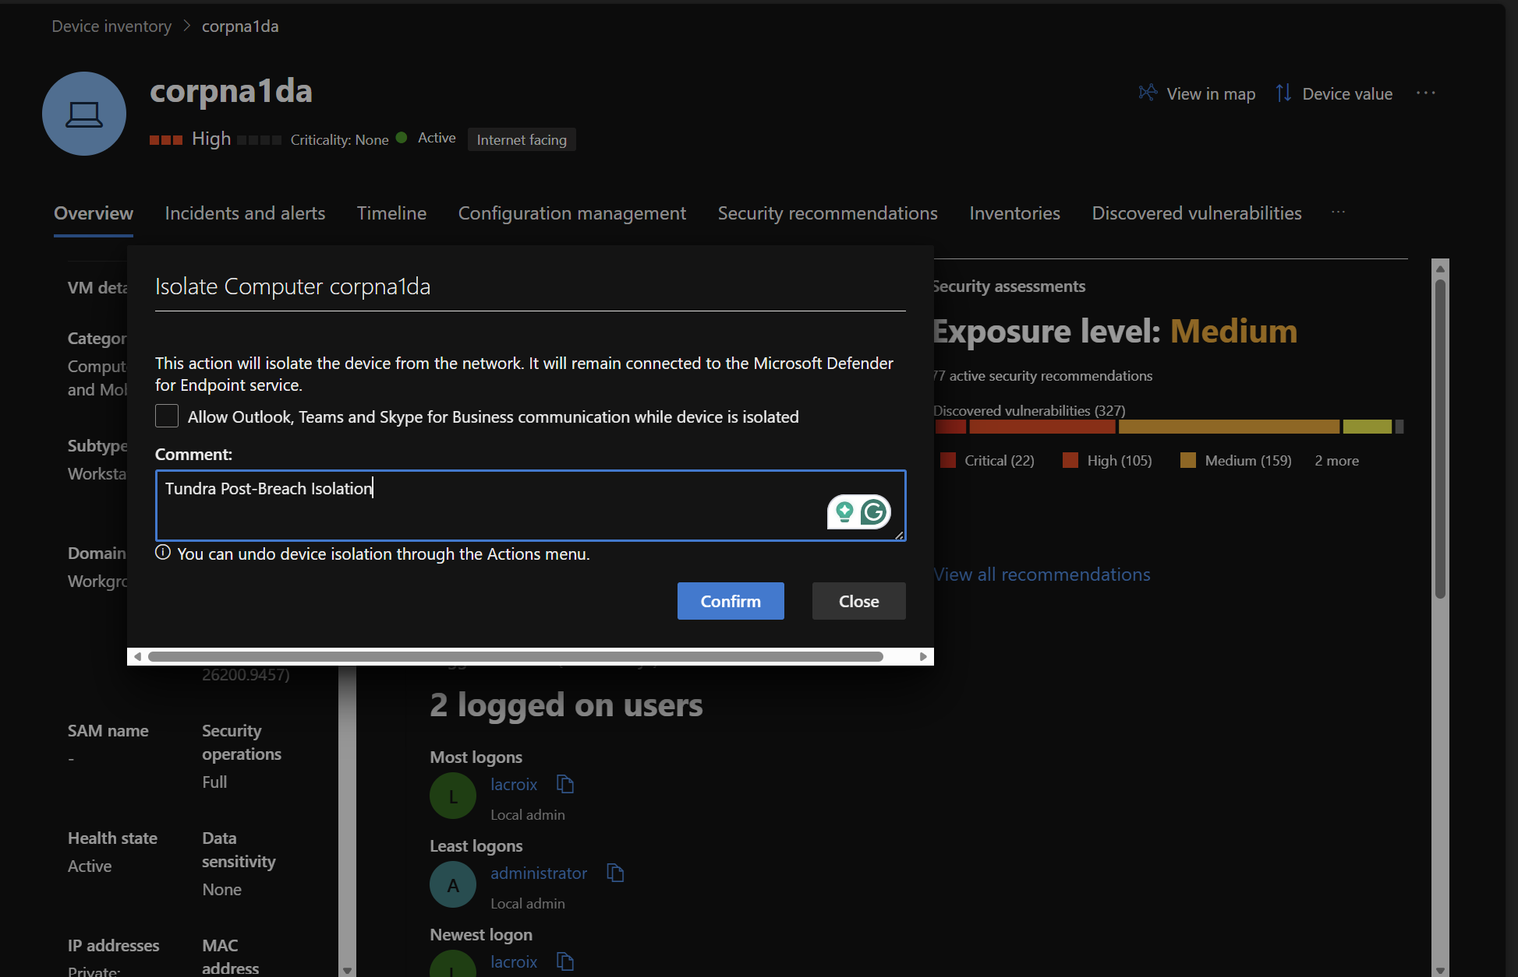
Isolating corpna1da in Defender
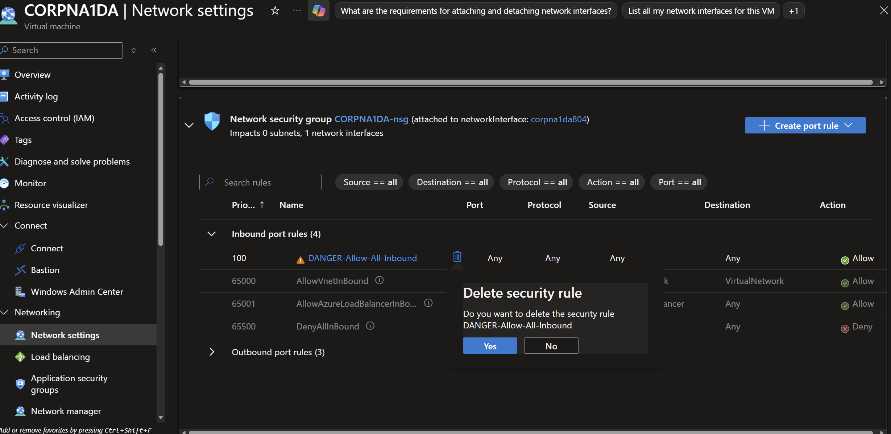
Deleting the DANGER-Allow-All-Inbound NSG rule
Two things were still open at the time of the post package and need to be part of eradication: MySQL was still listening on 0.0.0.0:3306 and 33060, and the Windows Firewall was still off.

Machine level forensic comparison (MDE investigation packages)

1. Baseline determination
Baseline: Tundra_Pre-Breach_Investigation_Package, collected Oct 7 at 22:39:53 UTC (3:39 PM PDT). Comparison: Post-Breach_MDE_Investigation_Package_1, collected Oct 9 at 20:38:08 UTC (1:38 PM PDT). I took both times from each package’s Forensics Collection Summary.csv, and the file names agree. The baseline was taken 4 minutes after root@'%' was created, so MySQL was already weak, but it is still clean: the first external probe of 3306 didn’t arrive until 4:54 PM.

2. Summary verdict
Compromise indicators found: yes, at the application layer only. Confidence: high for the MySQL compromise, moderate that the Windows host is clean. The packages show the database was destroyed by external actors, but no new persistence, accounts, services, tasks or attacker executables on the OS. Confidence on the host is moderate rather than high because the Security log rolled over and doesn’t cover Oct 8 (see Gaps).

3. Notable deltas
Category | Item | Change | Assessment | Evidence
Firewall | EnableFirewall 1 to 0 on Domain, Public and Standard profiles | Changed | Benign (my Phase 5 setup) | Autoruns, SharedAccess\Parameters\FirewallPolicy
Network | MySQL listening on 0.0.0.0:3306 and 33060 | Unchanged | Suspicious exposure, still open at collection | ActiveNetConnections.txt
Network | No established connections to external IPs other than Microsoft and Azure | Unchanged | Benign | ActiveNetConnections.txt
Security log | 362 failed RDP logons from 6 IPs, 13 administrator lockouts | Added | Suspicious: credential access (T1110.001) | Events 4625, 4740
Security log | No 1102 event; log covers Oct 9 04:10 to 20:38 UTC only | Changed | Benign rollover, but leaves a gap | Security.evtx
Prefetch | MYSQLDUMP.EXE, 3 runs, all Oct 8 19:27:18 UTC | Added | Benign: my Workbench Data Import | MYSQLDUMP.EXE-B534AD29.pf
Prefetch | ROBOCOPY, QUSER, QUERY, FINDSTR, XCOPY, SenseSampleUploader | Added | Benign: the MDE package collection itself | Prefetch run times Oct 9 18:46 to 20:38 UTC
Prefetch | CSC.EXE 112 runs on a regular cycle | Changed | Benign: PowerShell compiling helpers for Defender and the Azure agent | Includes vyegl45e.dll on Oct 8 at 12:21 PM
Defender log | mysqld.exe writing recover_your_data_info.ibd and recover_your_data.ibd; binlog index rewritten and .deleted | Added | Suspicious: impact (T1485) and indicator removal (T1070) | MPLog, Oct 8 15:52 and 23:12 UTC
Defender log | Zero threat detections | Unchanged | Consistent with no malware on the host | MPDetection log
Services | 274 in both; only per session service suffixes changed | Unchanged | Benign | Services.csv, events 4697
Scheduled tasks | 251 in both, no non Microsoft additions | Unchanged | Benign | ScheduledTasks.csv
Autoruns | Run keys only Edge and OneDrive in both | Unchanged | Benign | Autoruns.txt
Users and groups | Administrators = administrator, lacroix in both | Unchanged | Benign | LocalGroups.txt
BAM | No entries for the administrator account | Unchanged | Supports no interactive use | Autoruns, bam\State\UserSettings
User profiles | C:\Users\administrator does not exist | Unchanged | Supports no interactive use | administrator_TempDirFiles.txt
Installed programs | 9 in both | Unchanged | Benign | InstalledPrograms.csv
System | Boot time, NIC renamed Ethernet 5 to Ethernet 7 | Changed | Benign: nightly lab shutdown | SystemInformation.txt, event 1100
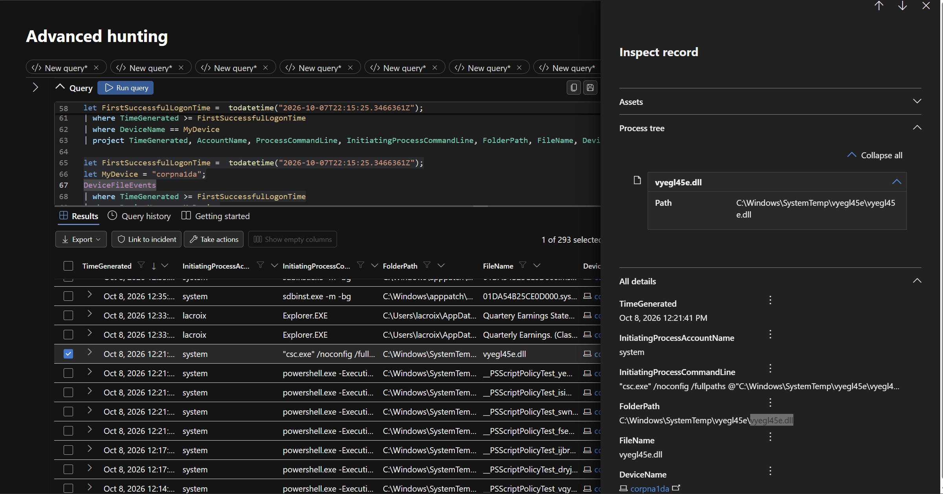
vyegl45e.dll written by csc.exe as SYSTEM at 12:21 PM, part of the normal PowerShell compile cycle

4. Strongest compromise indicators (prioritized)
- Destruction of all MySQL databases by external IPs (Impact, T1485). Defender’s log of mysqld.exe file writes at 15:52 and 23:12 UTC, backed by the full query log in MySQLAudit_CL.
- Data exfiltration over the attacker’s MySQL session (Exfiltration, T1041). 4.15 MB out to 45.128.199.171 in NSG flow logs.
- Binary log wipe (Defense Evasion, T1070). RESET MASTER and PURGE BINARY LOGS, matching the .deleted binlog index in the Defender log.
- Valid account use (Initial Access, T1078). MySQL root from 77.90.185.30, 45.128.199.171 and 64.89.163.178; RDP administrator from 80.94.95.83.
- RDP password guessing (Credential Access, T1110.001). 362 failures and 13 lockouts in the post package alone.

5. Probable incident type
Database extortion (a “read me” wipe and ransom), not file encrypting ransomware. Nothing was encrypted and nothing ran on Windows. Two independent groups found an internet facing MySQL with a guessable root password, copied or skipped the data, dropped it and left Bitcoin notes. This matches the long running automated MySQL extortion bots.

6. Gaps
- The Security log rolled over at its 20 MB cap. The post package starts Oct 9 04:10 UTC, so the whole Oct 8 attack window, including the 80.94.95.83 logon, is missing from the host log. Sentinel and MDE telemetry cover it instead.
- Process command line auditing (4688) was off. Only boot processes were logged.
- Windows Firewall logging was never enabled, so pfirewall.log doesn’t exist in either package.
- The hosts file, DNS cache history and browser artifacts aren’t part of the MDE package. The DNS cache held only one Microsoft entry.
- The baseline was collected after root@'%' was created, so it is a clean baseline of a weak system, not of the hardened build.

IOCs and MITRE ATT&CK mapping

IOCs
I searched both investigation packages for every indicator below. None appear in the baseline. In the post package, only the RDP brute force IPs appear (in the Security log). The MySQL attack IPs, wallets and note names don’t show up on the host at all, because every MySQL action happened inside the database and the Security log for Oct 8 had already rolled over.
Type | Indicator | Role | In post package
IP | 45.128.199.171 | Wave 1 attack node, received 4.15 MB | No
IP | 77.90.185.30 | Wave 1 credential checker | No
IP | 64.89.163.178 | Wave 2 attack node | No
IP | 64.89.163.167, 64.89.163.153 | Wave 2 password checks | No
IP | 80.94.95.83 | RDP administrator logon | No (Oct 8, before log window)
IP | 59.18.141.14, 80.66.83.43, 80.66.83.80, 175.139.147.237, 82.114.228.224, 138.91.109.48, 181.42.225.2, 188.132.201.21 | RDP brute force | Yes, 4625 events (except .43 and 82.114.228.224, Oct 8 only)
IP | 79.124.56.214 | Full port scan | No
BTC wallet | bc1q6axq3n2trxewd04cczsvtk7jqn6qp34d66cust | Wave 1 ransom | No
BTC wallet | bc1qt6kstjjdatqnxd3ksdcfv0jnhdjzndcnkx8zla | Wave 2 ransom | No
Email | ak+2s3ft@onionmail.org | Wave 2 contact | No
URL | https://cuq.in/844 | Wave 2 shortened link | No
Victim ID | 2S3FT | Wave 2 | No
Database object | RECOVER_YOUR_DATA_info table, READ_ME column | Wave 1 note | Yes, as .ibd file writes in the Defender log
Database object | RECOVER_YOUR_DATA database and table, text column | Wave 2 note | Yes, as .ibd file writes in the Defender log
Query | SHOW DATABASES LIKE 'mat_server' | Wave 1 tool fingerprint | No
Query | RESET MASTER followed by PURGE BINARY LOGS | Wave 2 anti forensics | Side effect only (.deleted binlog index)

MITRE ATT&CK
Tactic | Technique | Evidence
Reconnaissance | T1595.001 Active Scanning | 79.124.56.214 port sweep; 29 IPs probing 3306 and 33060
Credential Access | T1110.001 Password Guessing | RDP brute force, 362 failures and 13 lockouts on Oct 9
Initial Access | T1078 Valid Accounts | MySQL root (both waves); RDP administrator from 80.94.95.83
Initial Access | T1190 Exploit Public Facing Application | MySQL root reachable from the internet
Discovery | T1082 System Information Discovery | SHOW DATABASES, SHOW TABLES, database size queries
Collection | T1213 Data from Information Repositories | Wave 1 SELECT * ... SQL_NO_CACHE on every table
Exfiltration | T1041 Exfiltration Over C2 Channel | 4.15 MB returned over the attacker’s own MySQL session
Persistence / Privilege Escalation | T1098 Account Manipulation | Wave 2 GRANT CREATE, DROP on root@'%'
Defense Evasion | T1070 Indicator Removal | RESET MASTER, PURGE BINARY LOGS
Impact | T1485 Data Destruction | 30 dropped tables (Wave 1), 4 dropped databases (Wave 2)
Impact | T1531 Account Access Removal | REVOKE ALL PRIVILEGES from root@'%'
Impact | T1489 Service Stop | SHUTDOWN attempt (failed)
Impact | T1657 Financial Theft | Bitcoin ransom notes

Lessons learned and recommendations

What I took away from this
- An exposed database with a weak root password gets hit fast and more than once. It took under 18 hours for the first wipe, and a second group showed up the same afternoon. Neither group needed an exploit, just a password off a list.
- Shipping logs off the box saved the investigation. Wave 2 wiped the binary logs locally, but every query had already landed in Log Analytics. Without the DCR, I would have had a dropped database and no story.
- My MySQL detection fired on me, not the attackers. The rule had no localhost filter and what looks like a one day suppression, so my own admin logins used up the alert and both waves went by silently. A detection that only fires on the defender is a detection gap.
- Egress blocking doesn’t stop this kind of theft. The data went out as the reply to the attacker’s own inbound connection, so the tenant’s outbound rules never saw it. Inbound exposure was the real control that failed.
- The ransom notes were not honest. Wave 2 claimed a backup of data it never touched. Paying either group would not have reliably brought anything back.

Eradication and recovery
Since both MySQL and the administrator credential were compromised, the cleanest path is to rebuild the VM and restore the database from backup. If I keep the VM:
- ☐ Keep the VM isolated until hardening is done, then remove isolation
- ☐ Run a full Defender scan
- ☐ Turn the Windows Firewall back on for all profiles
- ☐ Delete the administrator account and disable Guest
- ☐ Set bind-address back to 127.0.0.1 in my.ini and restart MySQL80
- ☐ Drop root@'%', or give it a strong password and limit it to a known source IP
- ☐ Restore na_corp_01 from backup and rotate any real passwords that were in the credentials table
- ☐ Keep the NSG closed to 3306, 33060 and 3389; use Azure Bastion or Just in Time access for RDP

Detection improvements
- ☐ MySQL rule: exclude localhost, drop suppression, match run frequency and lookback (5 minutes), and map IpAddress and Username as entities
- ☐ New rule: any DROP DATABASE, DROP TABLE burst, RESET MASTER or PURGE BINARY LOGS in MySQLAudit_CL
- ☐ New rule: a table or database named like recover_your_data
- ☐ Raise the Security log size above 20 MB, turn on 4688 command line auditing, and enable firewall logging so the host keeps its own record of an attack window
- ☐ Add the IOCs above to an indicator list and report the IPs and wallets to AbuseIPDB

Overall, this lab was another great learning experience and one of my favorites. I got to start from the very beginning: creating the VM and the SQL environment, linking the device and its logs to Microsoft Defender for Endpoint, setting up an intentional honeypot, collecting data from real attackers, and then practicing isolation and remediation. This is usually something I read about or do in separate lab environments, but this time I did everything from start to finish while taking screenshots and keeping notes for this final report. I am now more confident than ever moving around Azure and Defender, and I know what a real attack looks like against an environment I built myself. Learning how to ship the SQL logs into Log Analytics so I could query them in Defender was also a great experience, since I was used to doing that in Splunk, so it was good to expand my skill set. Great time and another writeup for my portfolio!

